**From The Venetian Times  
BREAKING NEWS!!**

OTHELLO CAUSES CARNAGE

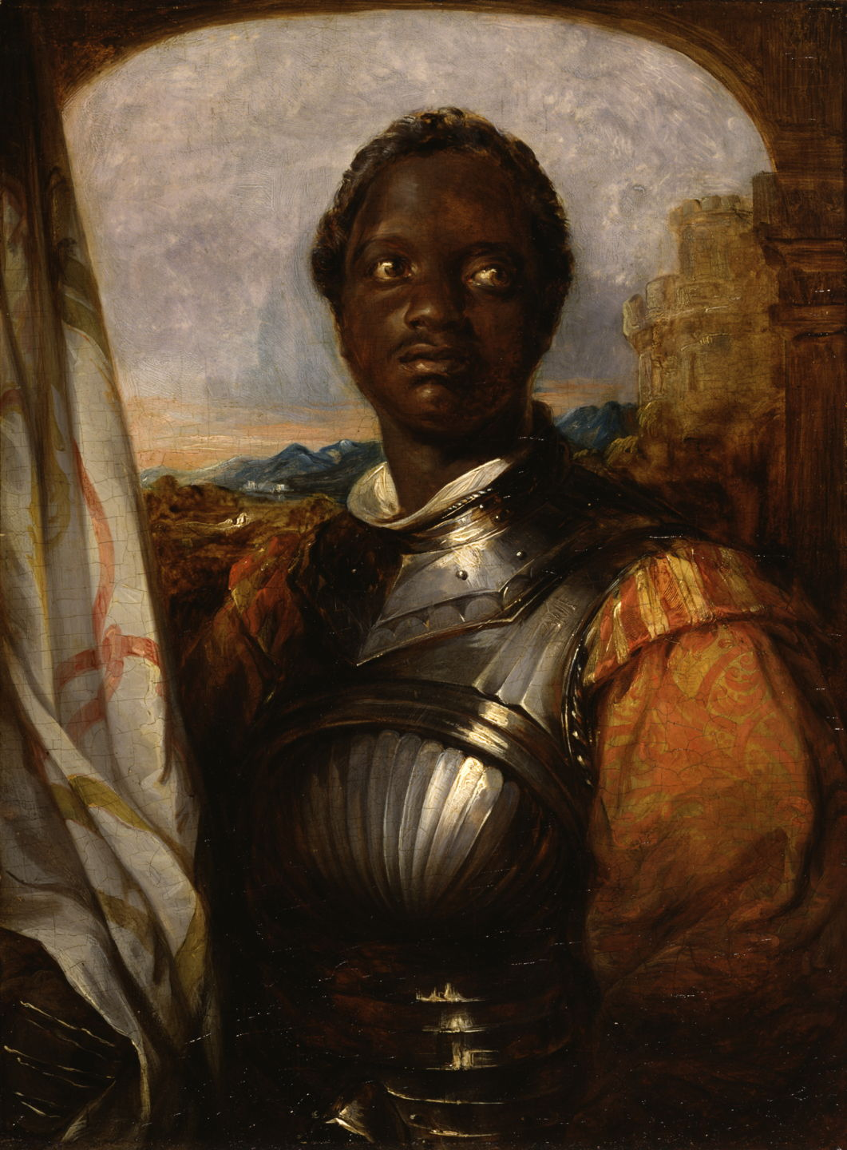General Othello rampages ending in many fatalities and injuries.  
  
After General Othello supposedly received the “news” that his wife, Desdemona was having an affair with a supposed friend, Cassio, he flew into a rage and made a sudden and rash decision to KILL Desdemona. After realizing it was all just an evil plot by another peer, Iago, Othello attempted to take revenge on him however was not able to kill him. After Othello then realized the gravity of his actions, he took it upon himself to end his life, leaving 2 dead and a sour taste in Iago’s mouth.

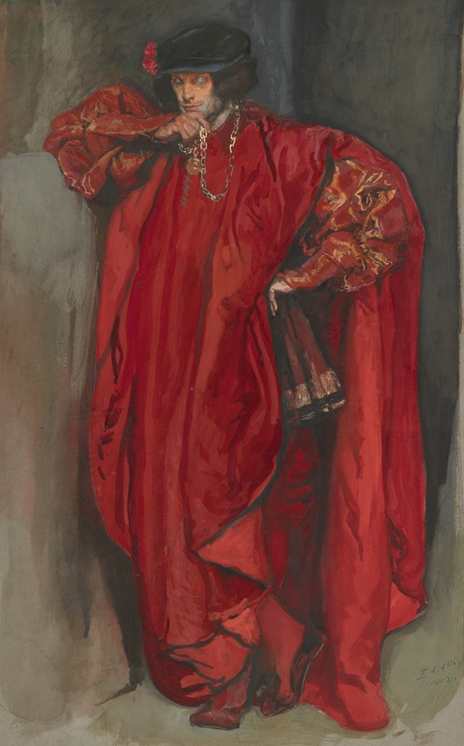

Iago was a master manipulator who always wanted to get his way and after believing Othello gave a promotion to Cassio over him, wanted revenge and he decided he would manipulate Othello into believing that his wife was having an affair with Cassio. Why he thought this was a good revenge plot, we do not know. His poor decisions ended in the deaths of the innocent and a scar of his own to remember this lesson by.

The public have mixed opinions on this tragedy, some say Othello is to blame while others say Iago is at fault.

We would love to hear your opinion on the matter, was Iago heartless, or was Othello too foolish. Feel free to answer our questionnaire on the matter which is available for collection when the messenger does his rounds.